**Module-8: Jenkins Assignment - 1**

You have been asked to:

● Trigger a pipeline using Git when push on Develop branch

● Pipeline should pull git content to a folder

Created 2 instances

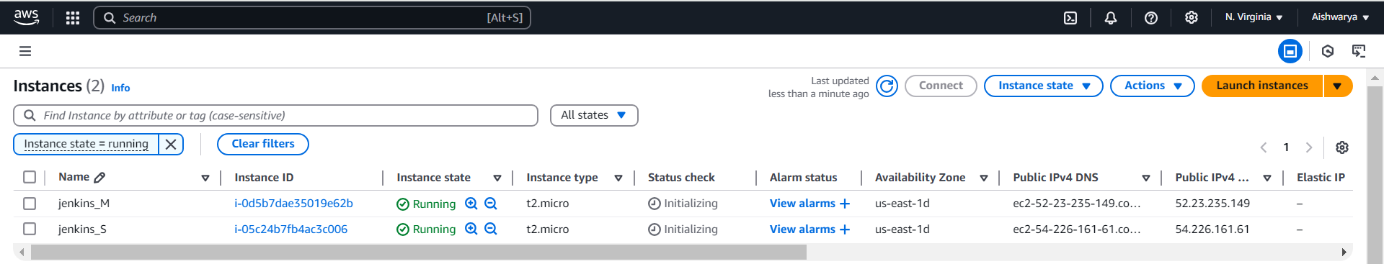

Update package and Install java version 17 on both master and slave machine

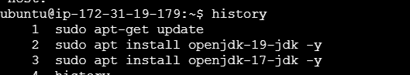

Jenkins needs to be installed only on master machine



Cmd to install Jenkins:

sudo wget -O /usr/share/keyrings/jenkins-keyring.asc \

https://pkg.jenkins.io/debian-stable/jenkins.io-2023.key

echo "deb [signed-by=/usr/share/keyrings/jenkins-keyring.asc]" \

https://pkg.jenkins.io/debian-stable binary/ | sudo tee \

/etc/apt/sources.list.d/jenkins.list **>** /dev/null

sudo apt-get update

sudo apt-get install jenkins

take public Ip address of master machine where Jenkins installed.

http:public_Ip:8080

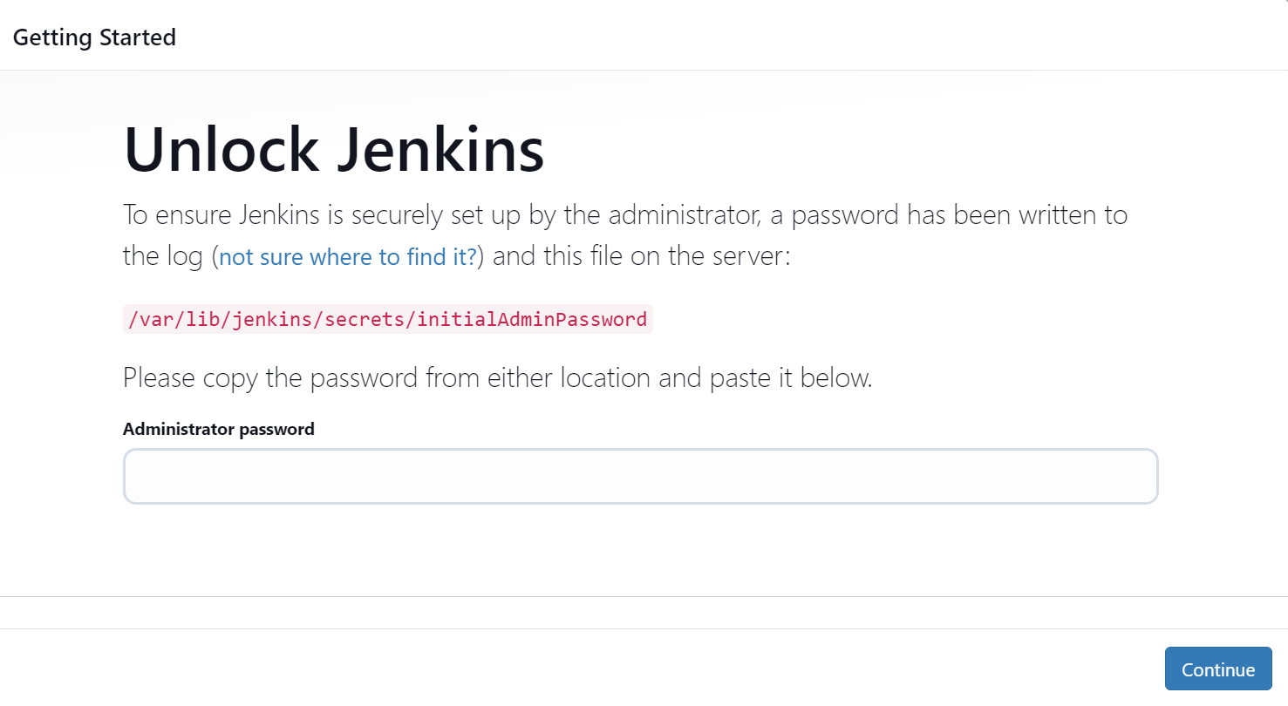

To see jenkins installed

Cmd: service jenkins status

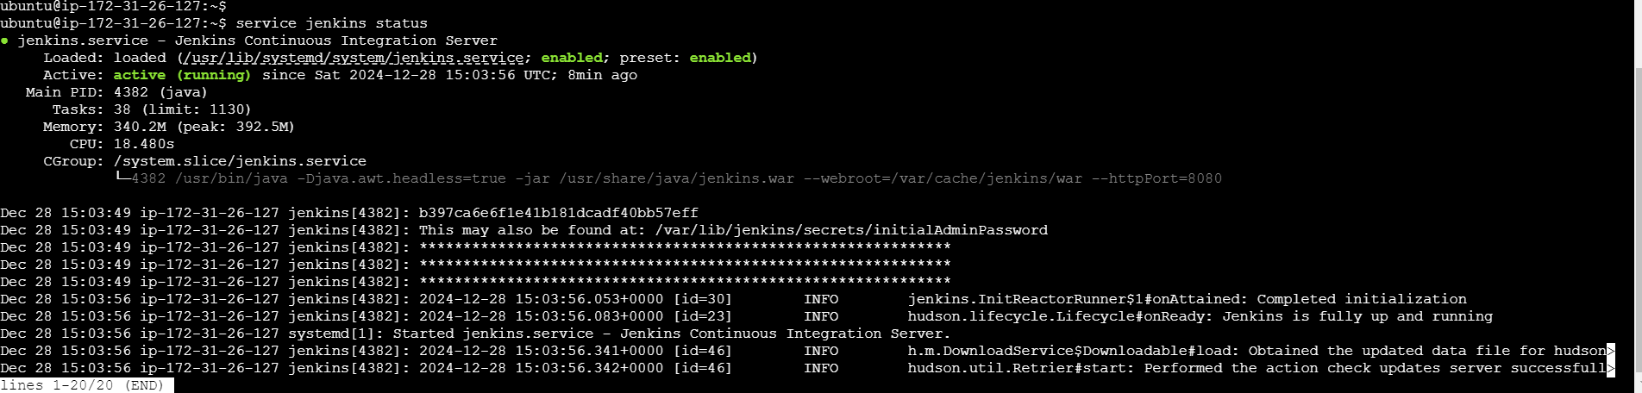



Go to the path and take password and enter from master machine

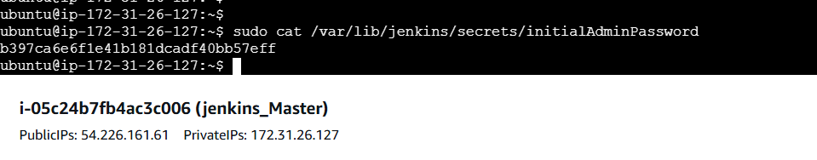

Take the password and login

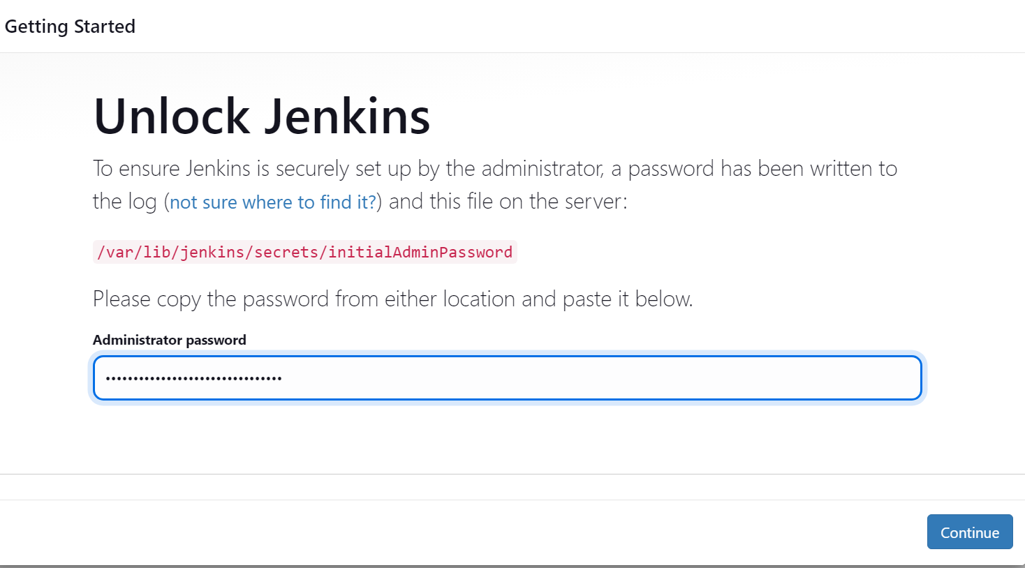

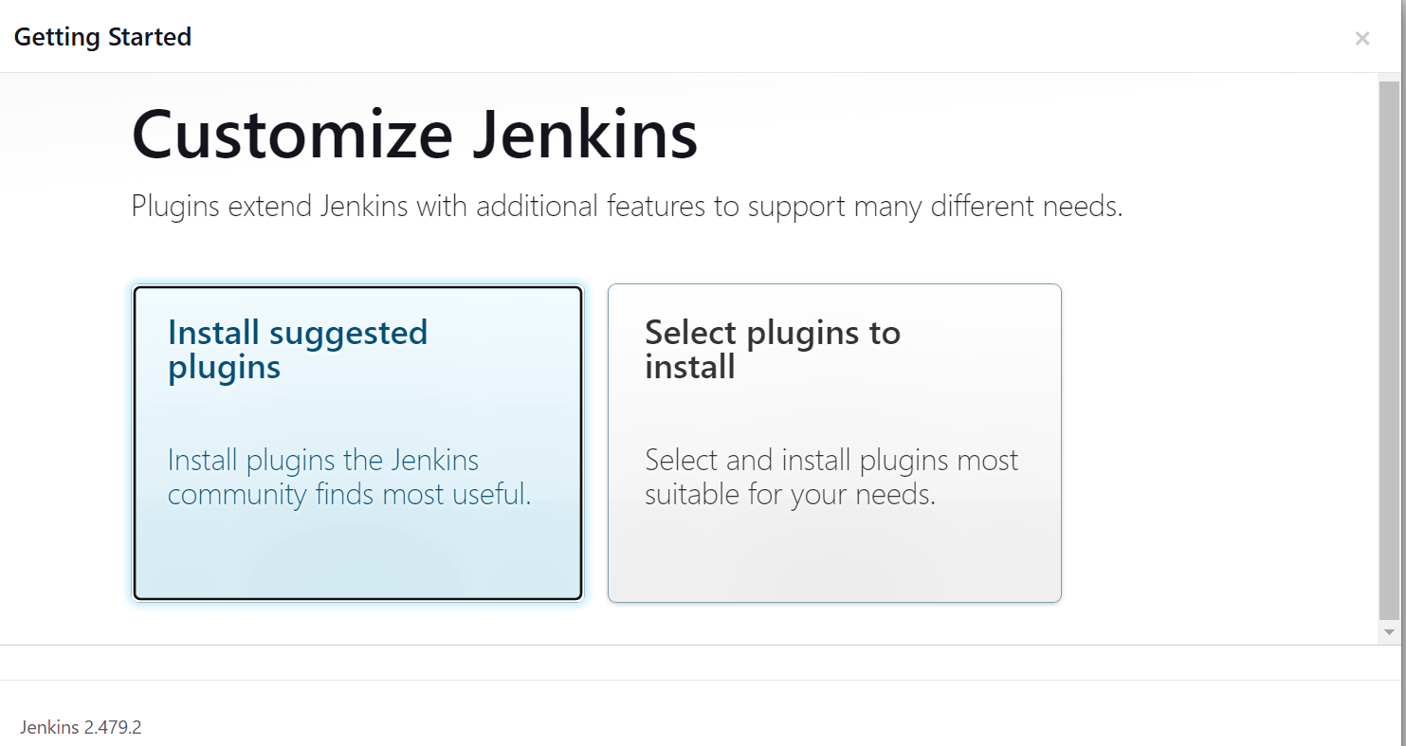

Create user

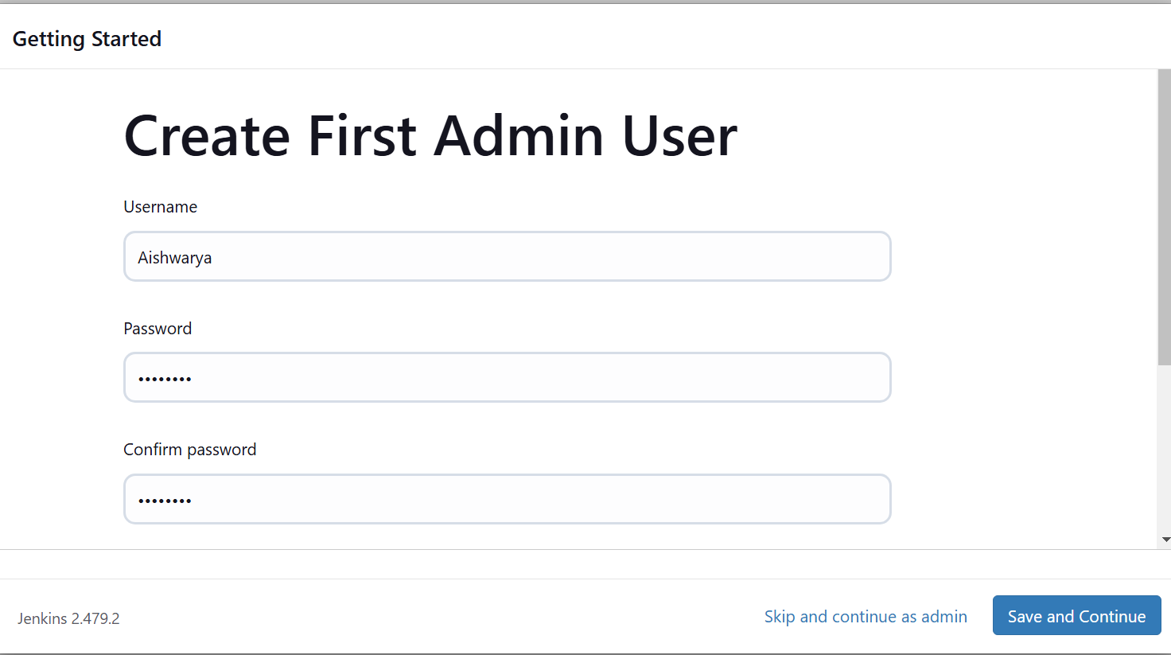

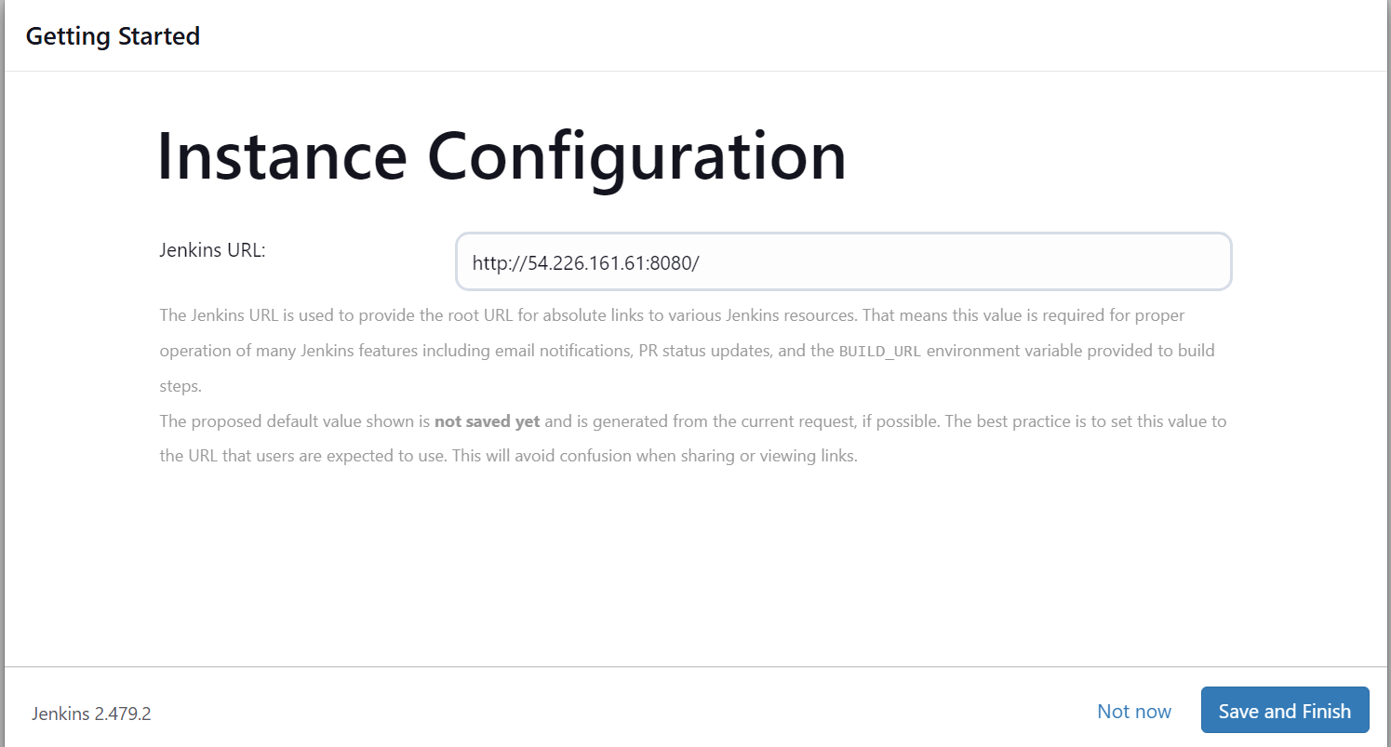

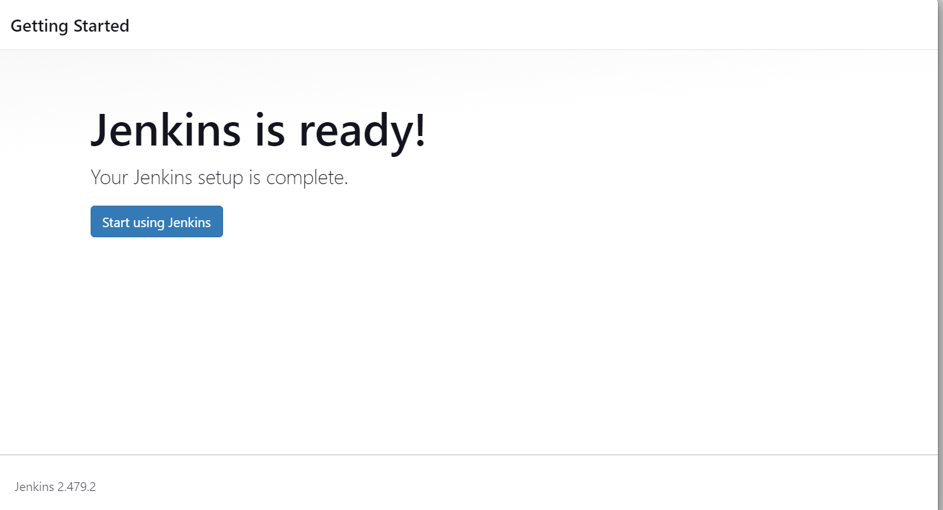

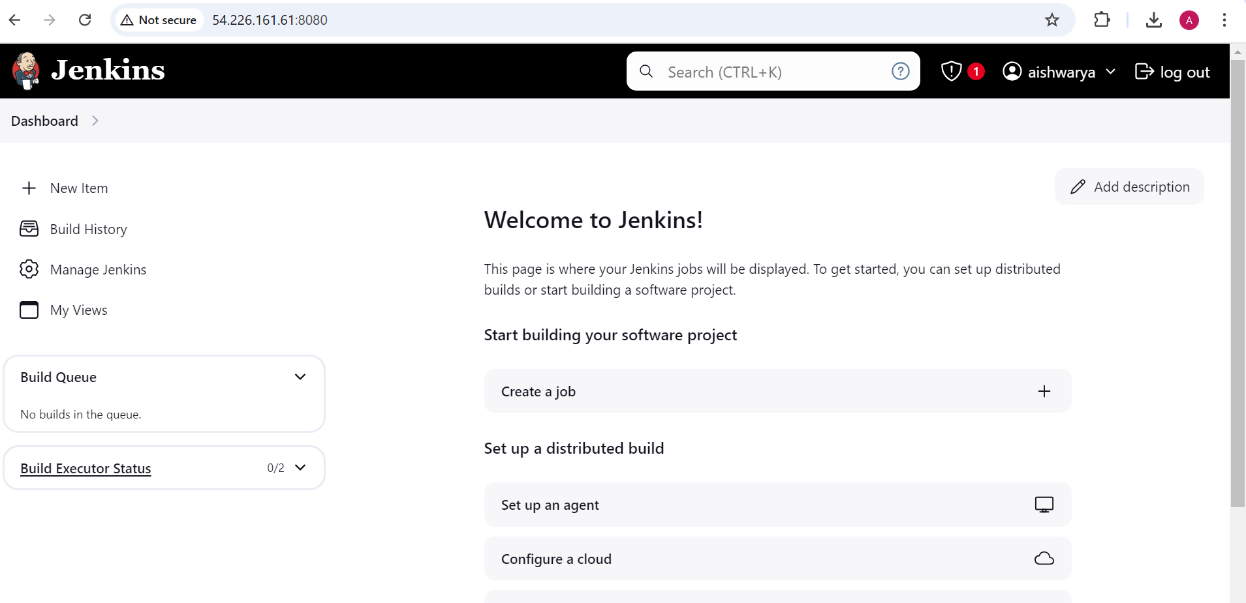

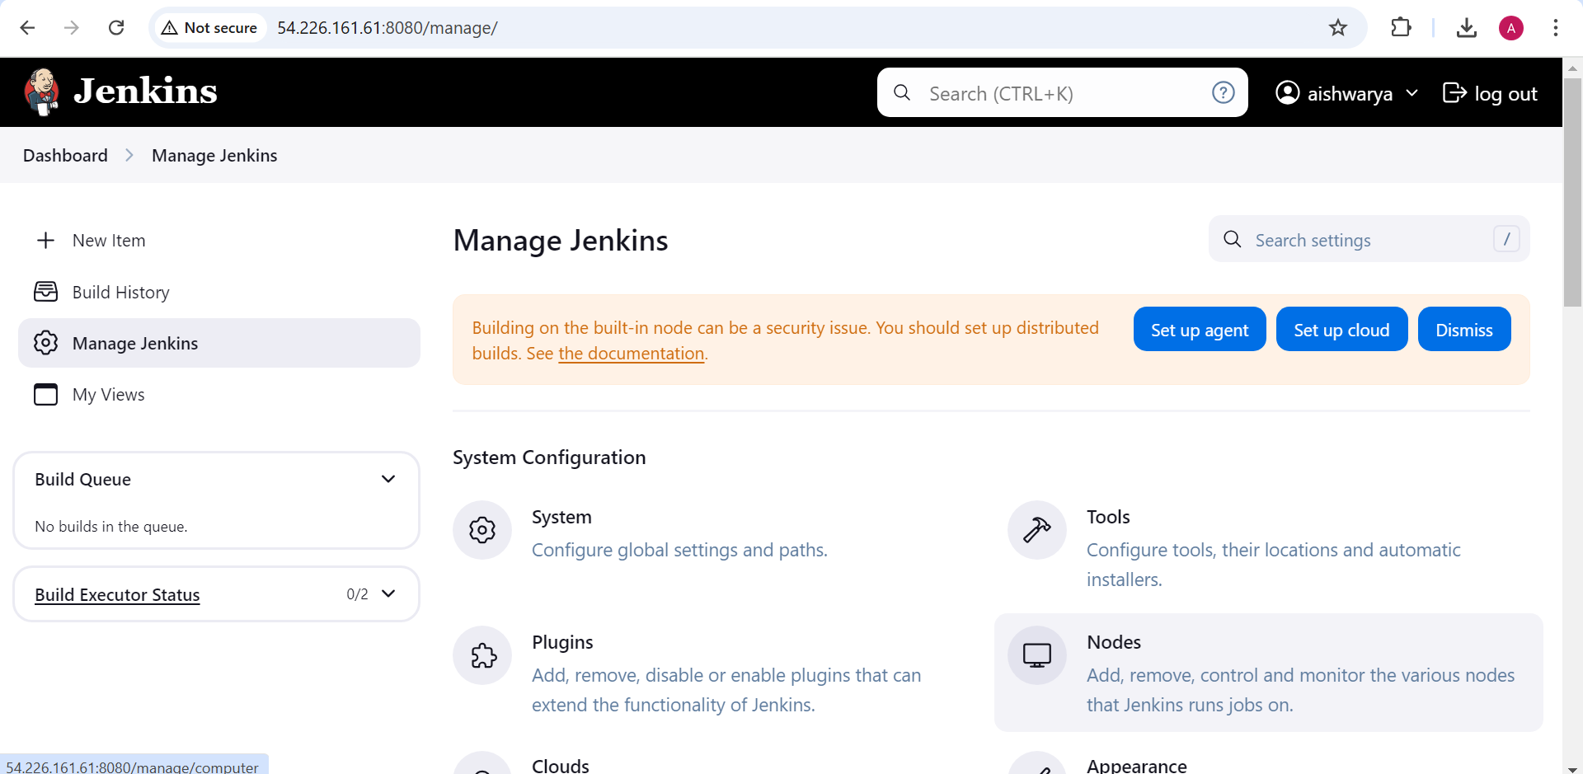

New node

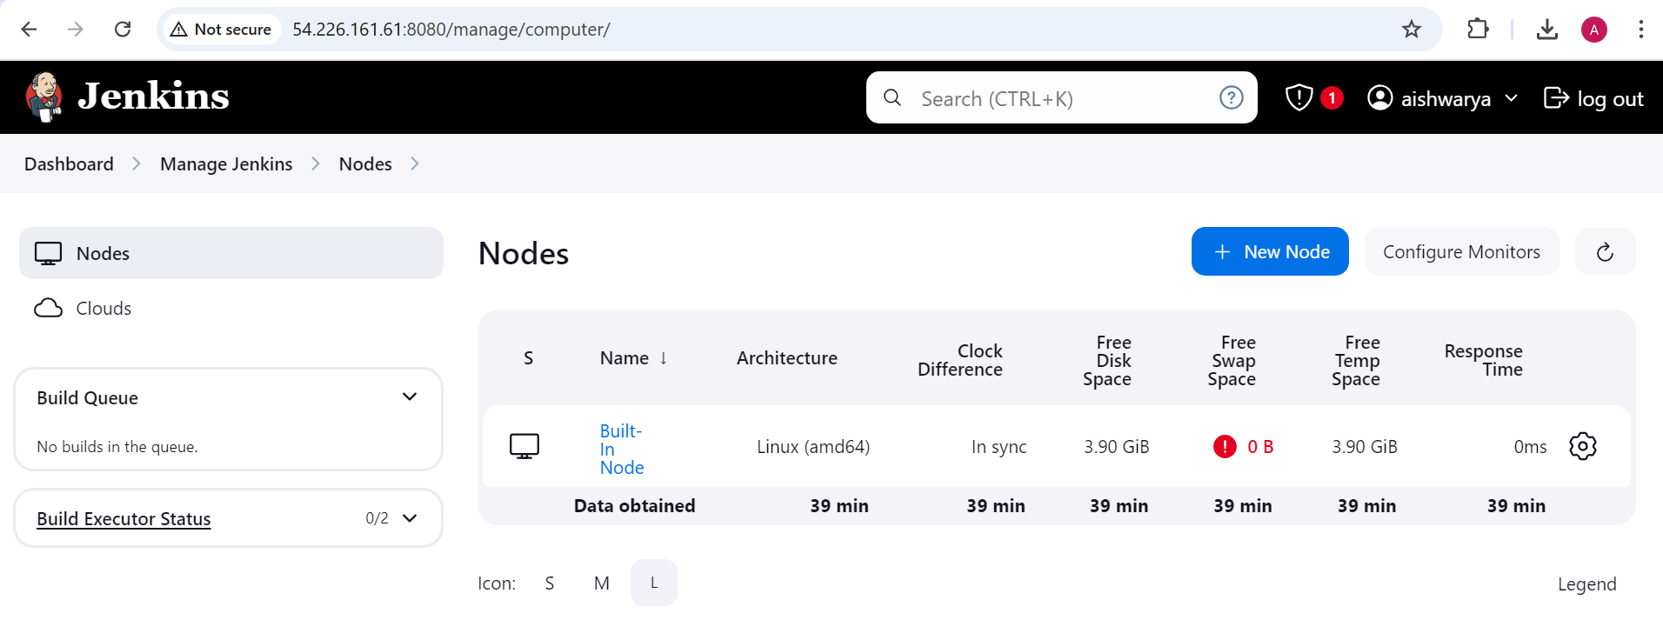

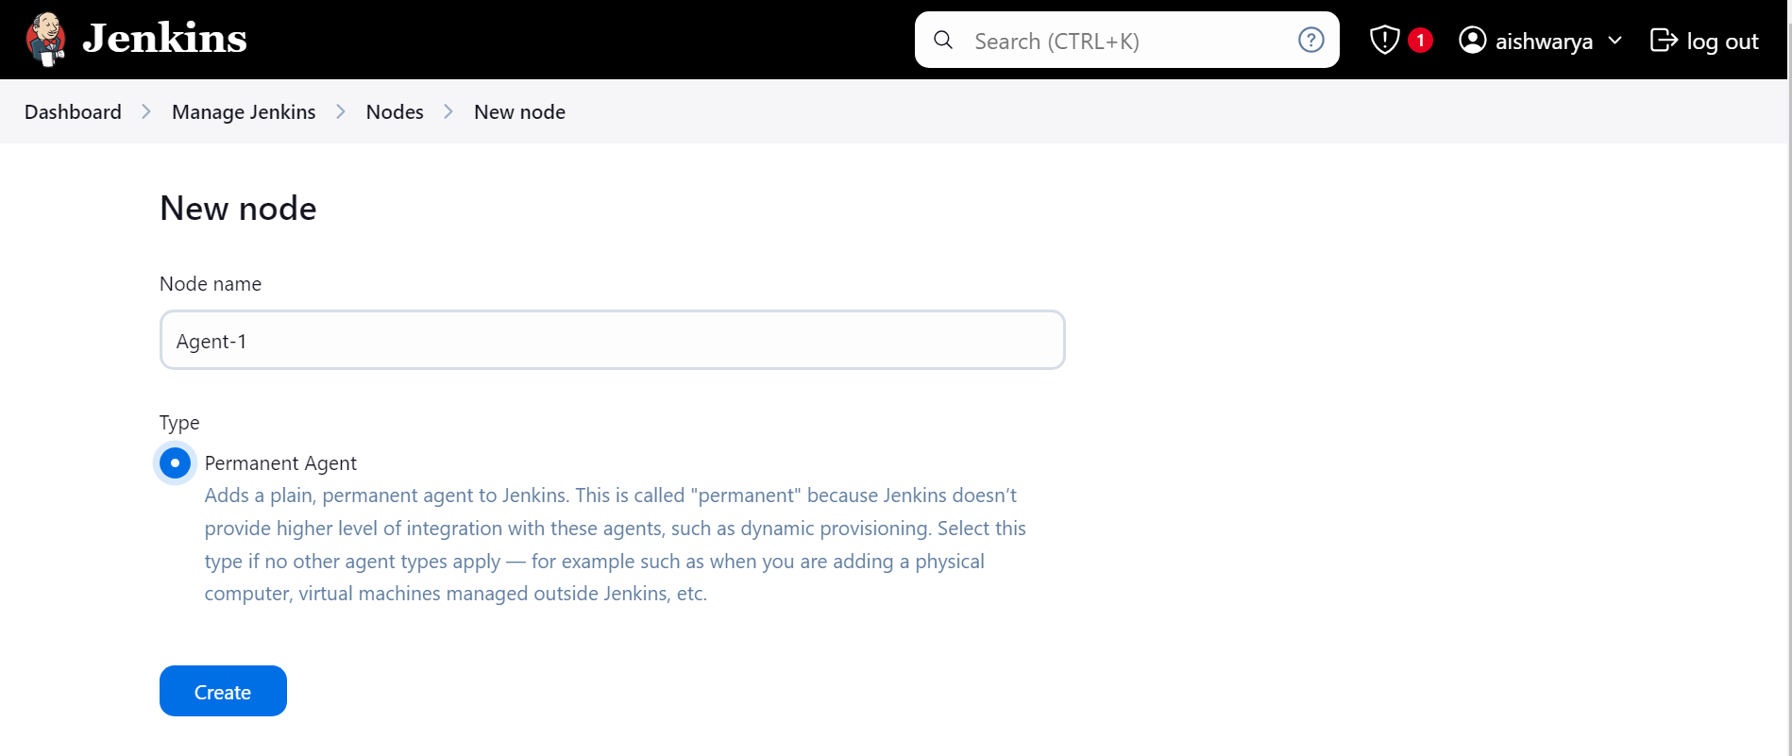

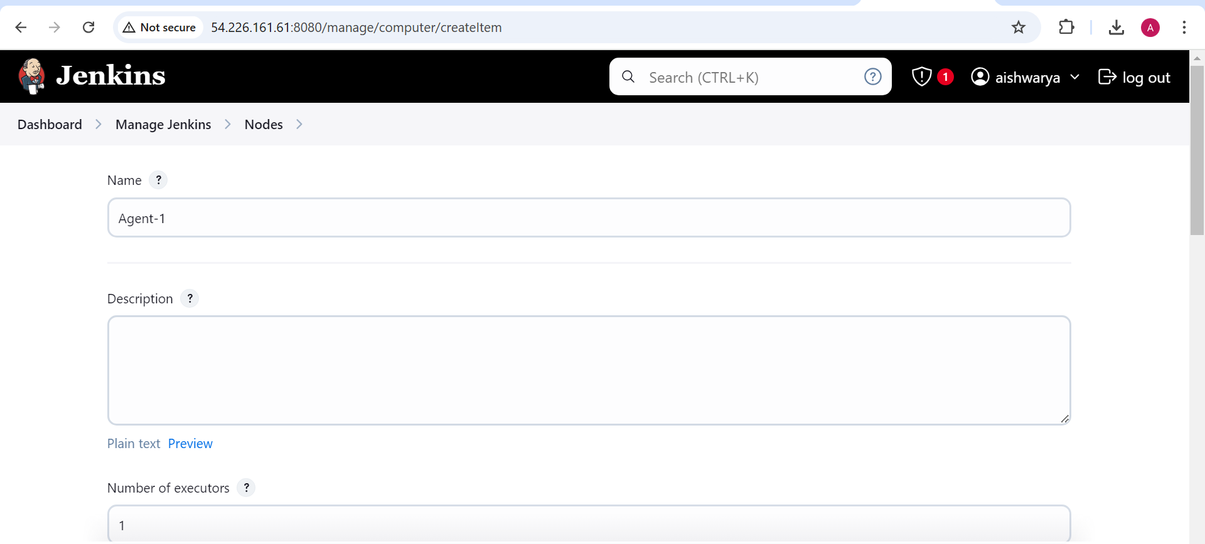

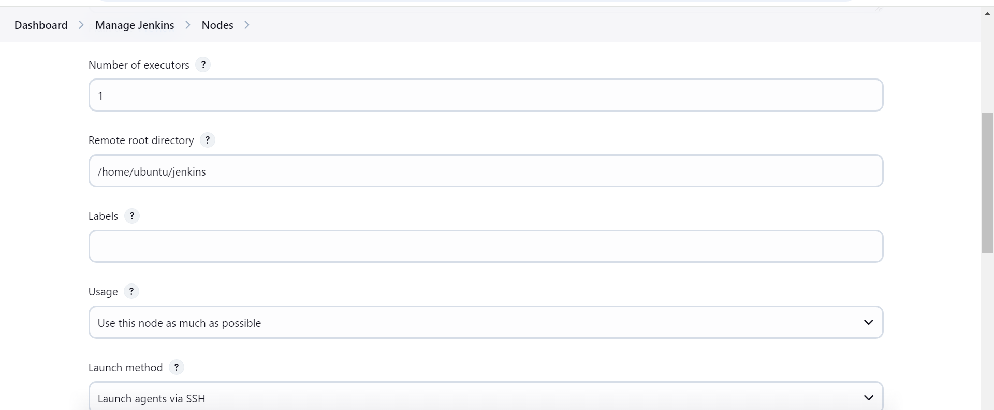

Give private ip of the slave

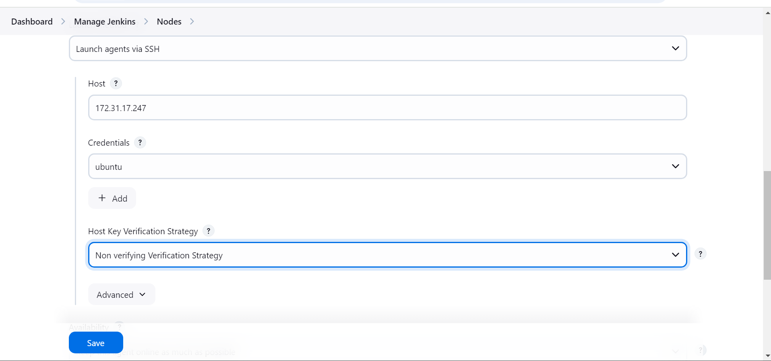

Create credentials

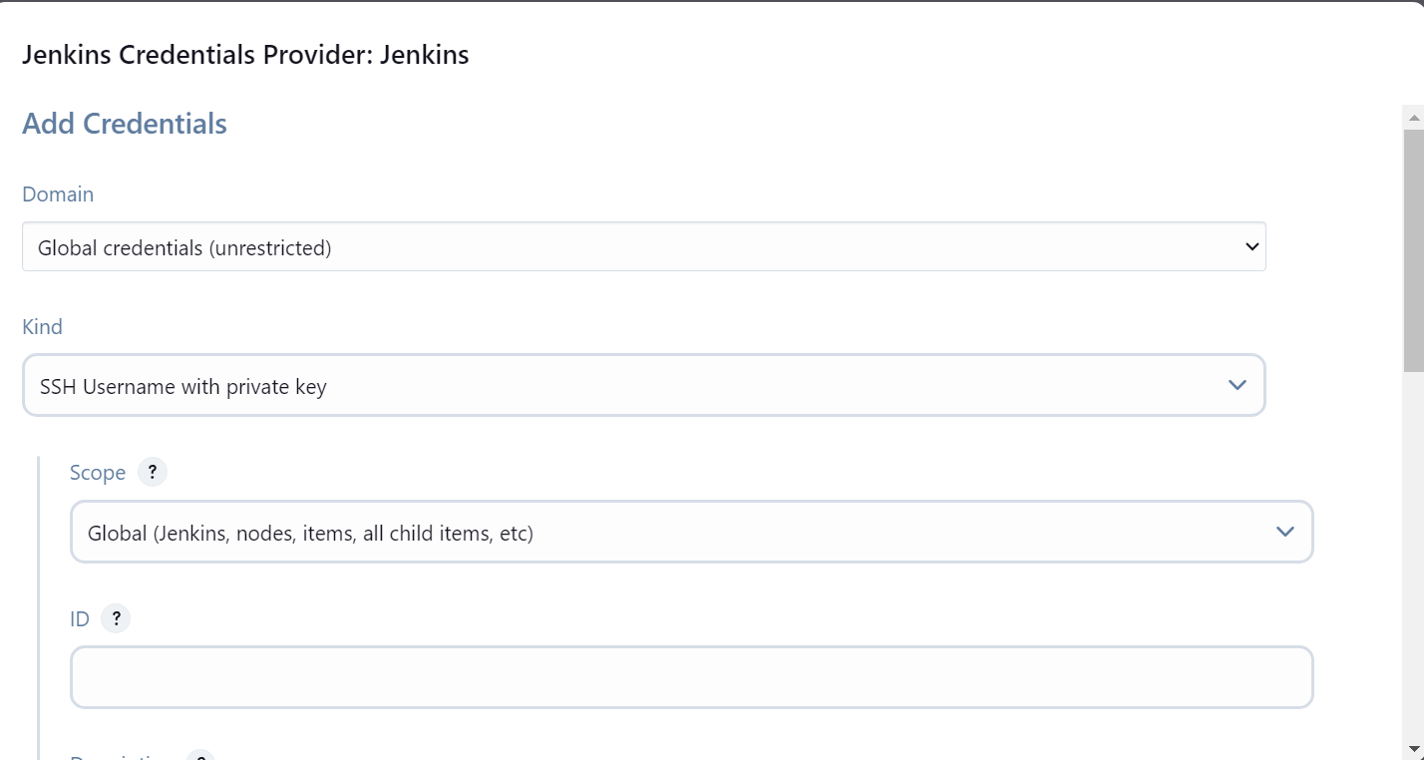

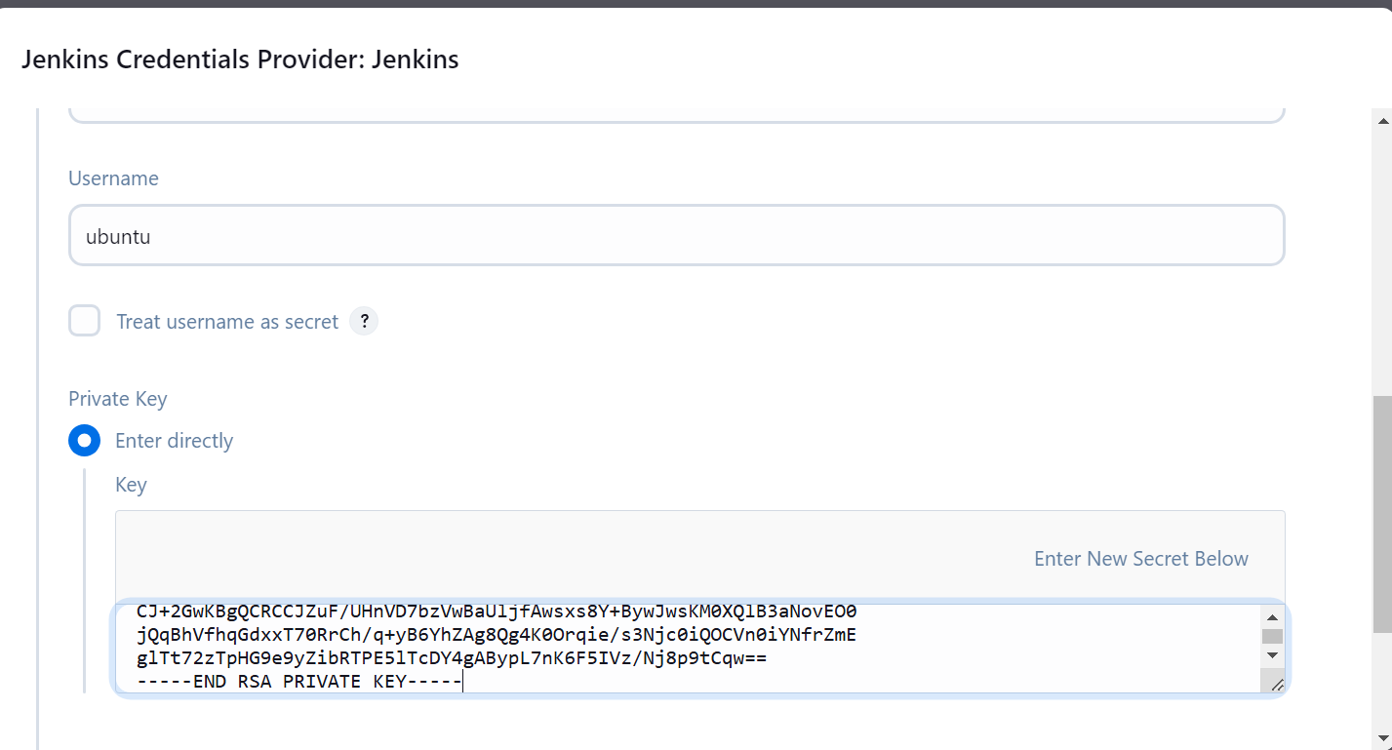

Now agent is up

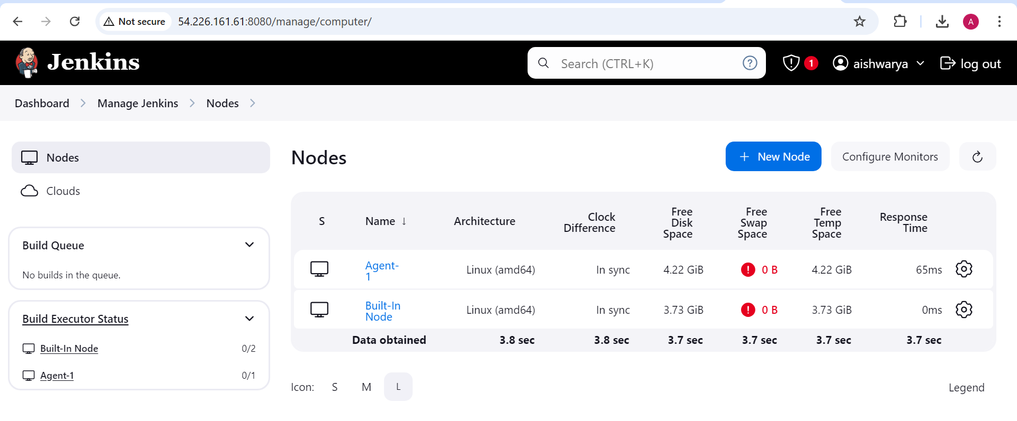

Go to the Github account and create the repo

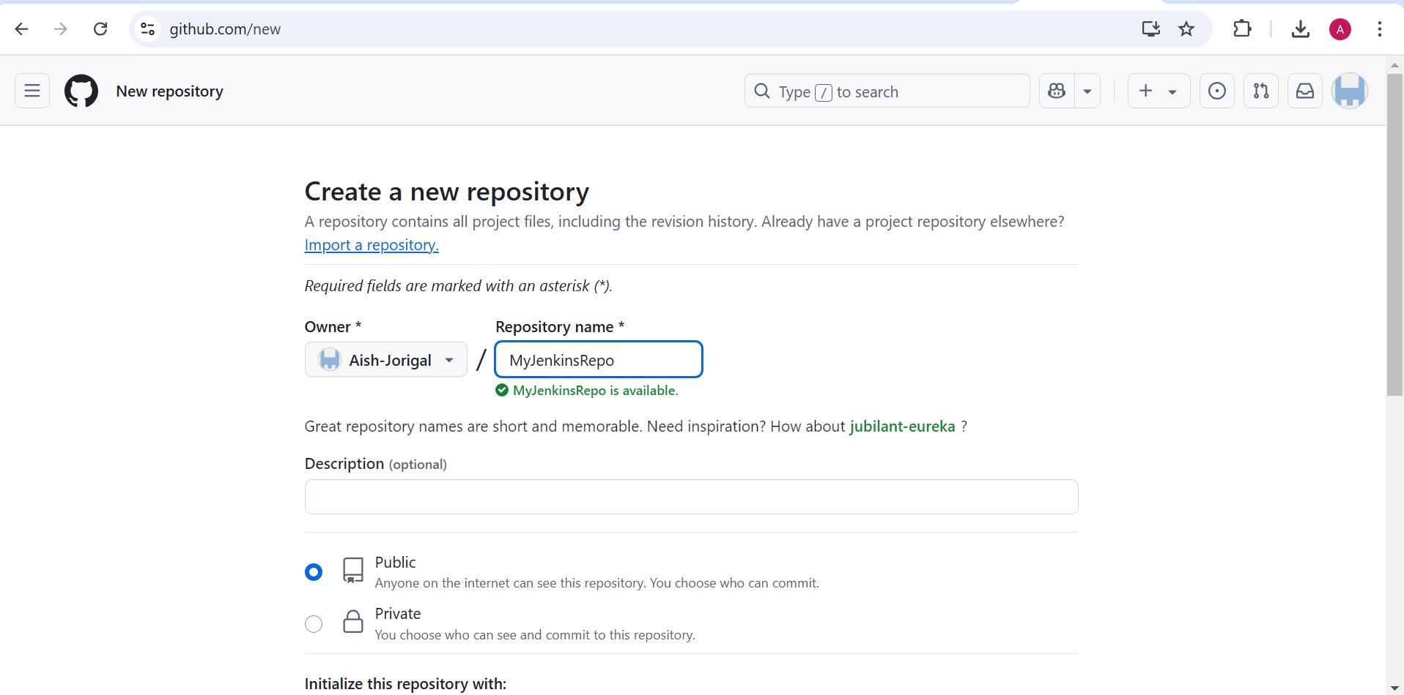

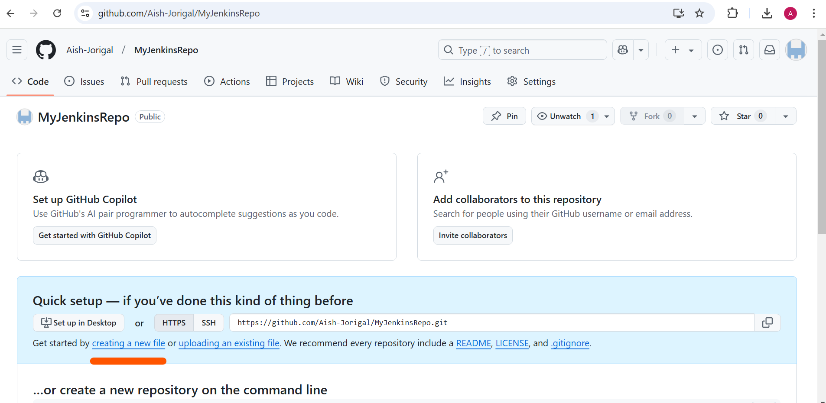

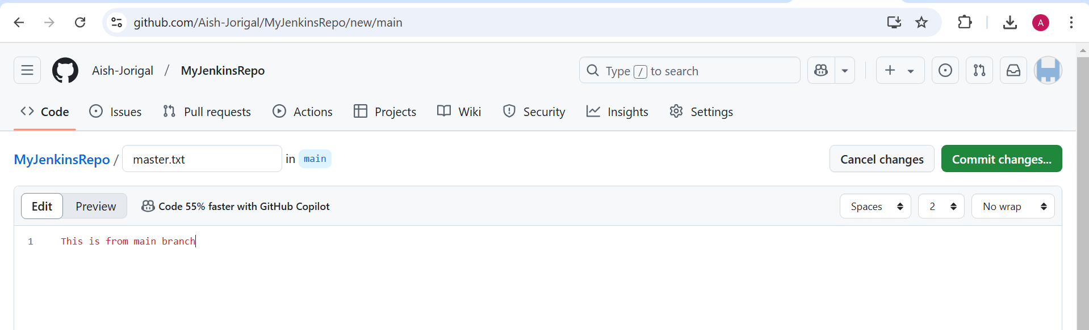

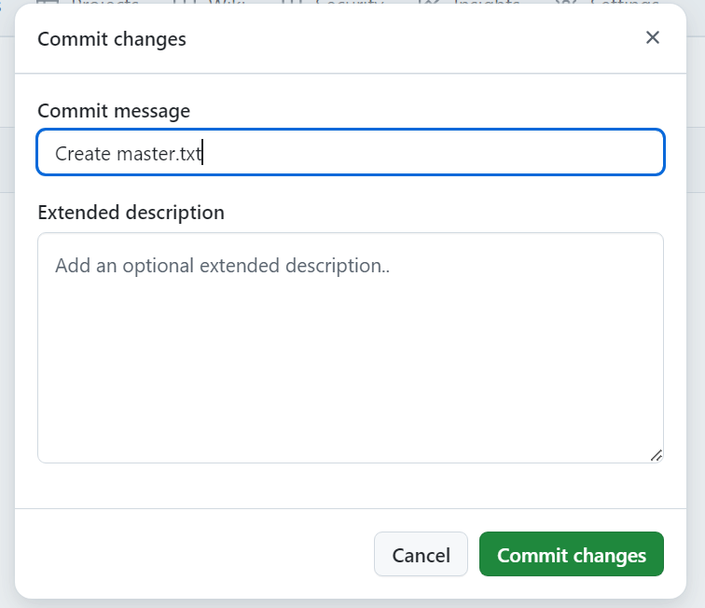

Create new branch 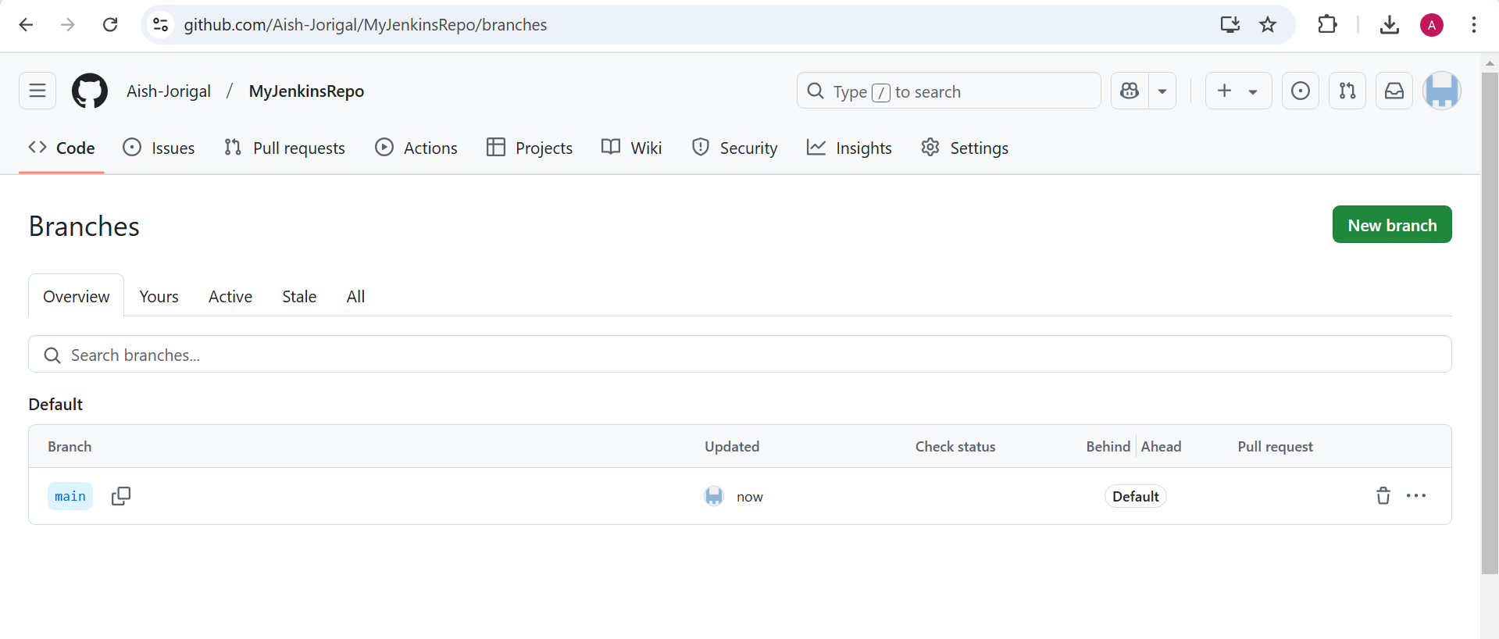

Create develop branch as per assignment

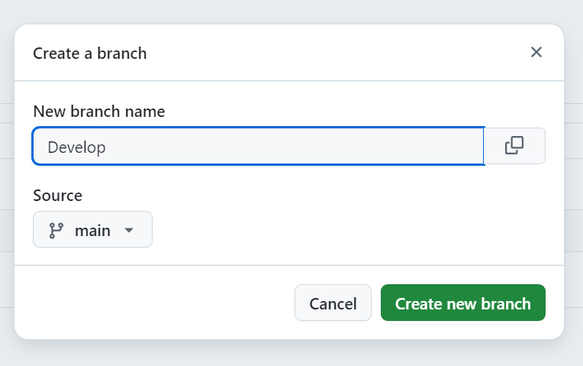

On Develop branch create new file 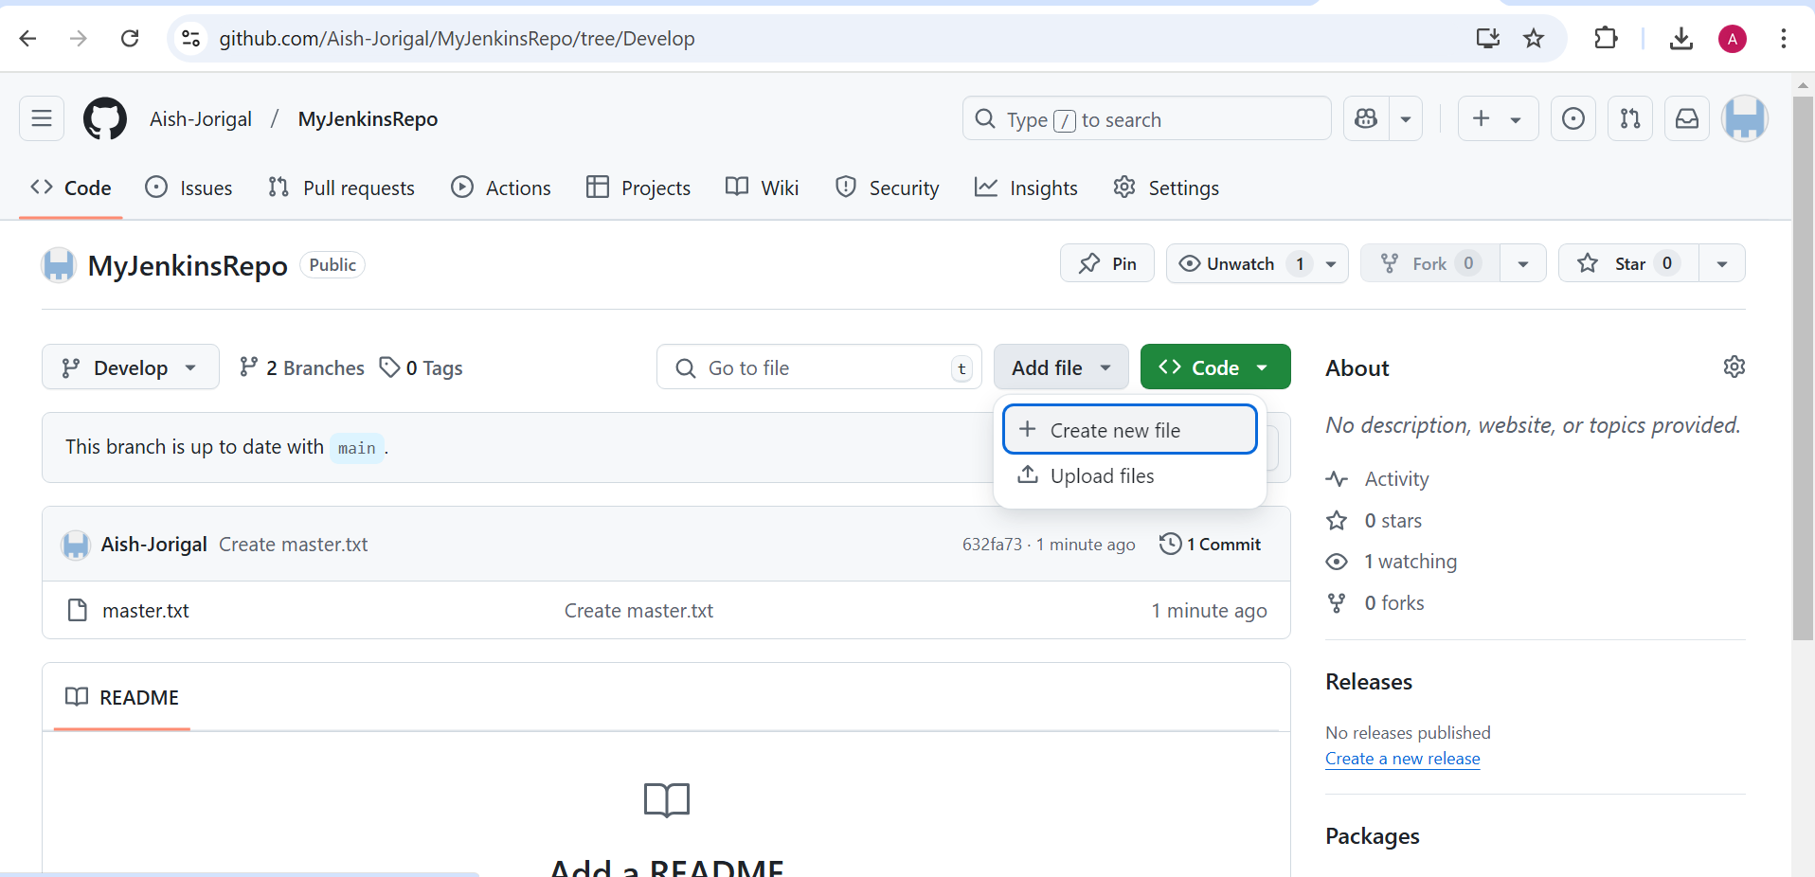

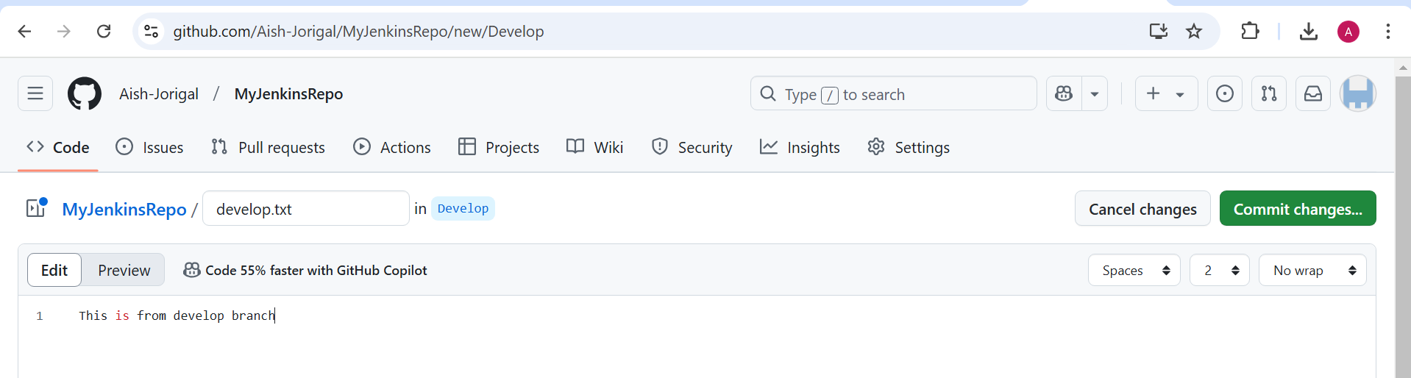

On slave node the jenkins folder is created when we put remote

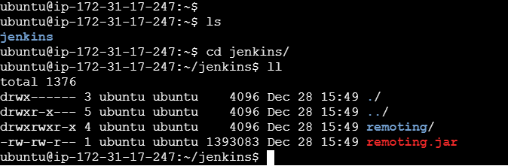

Create wehbo

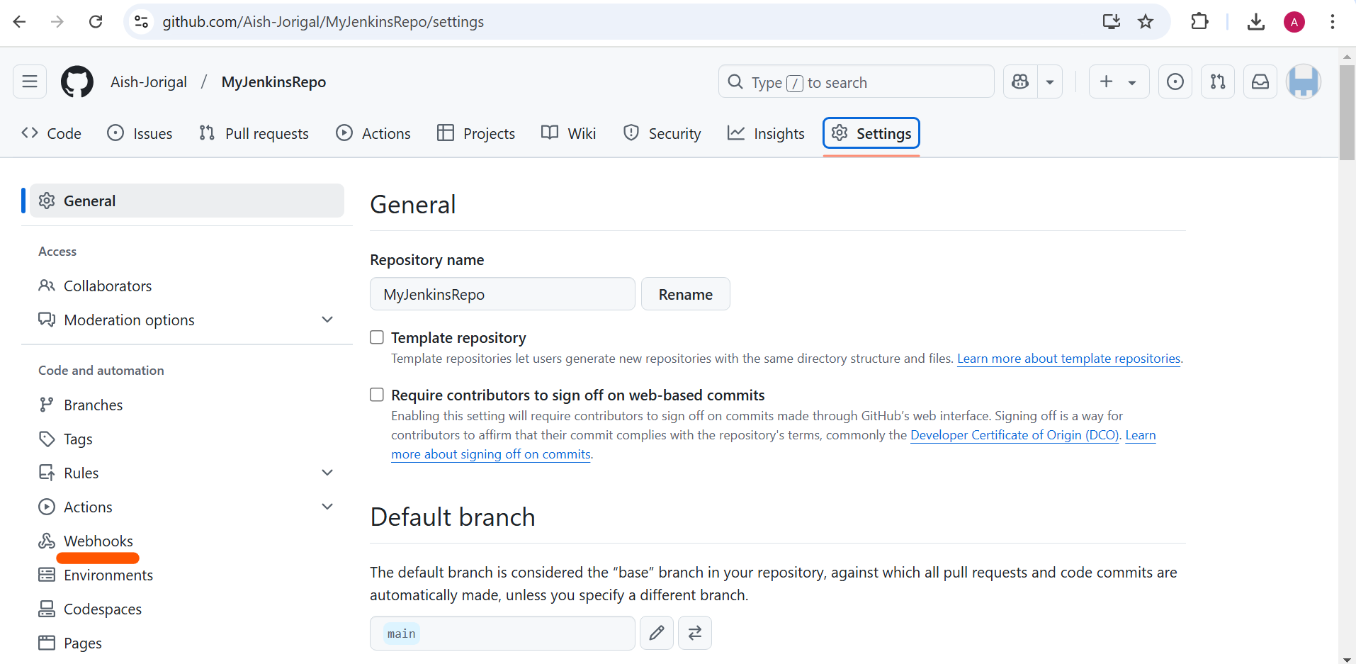

In payload give jenkins home address

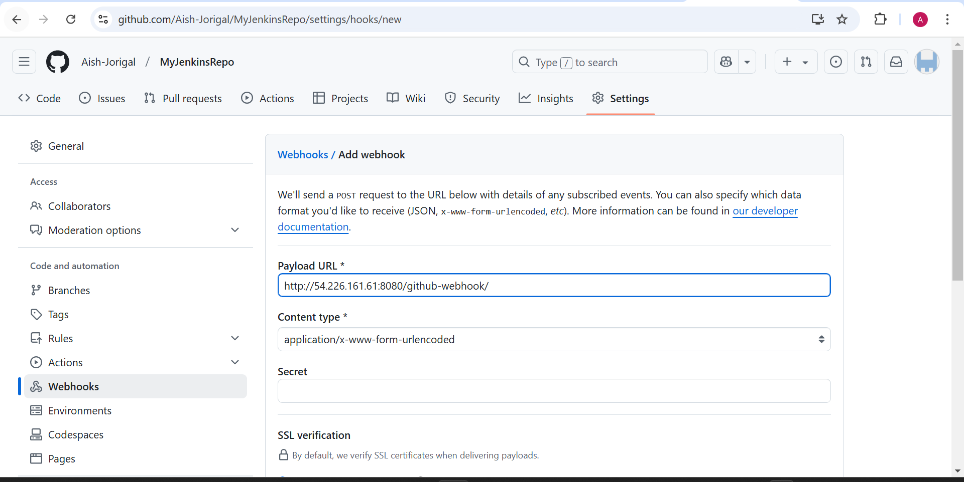

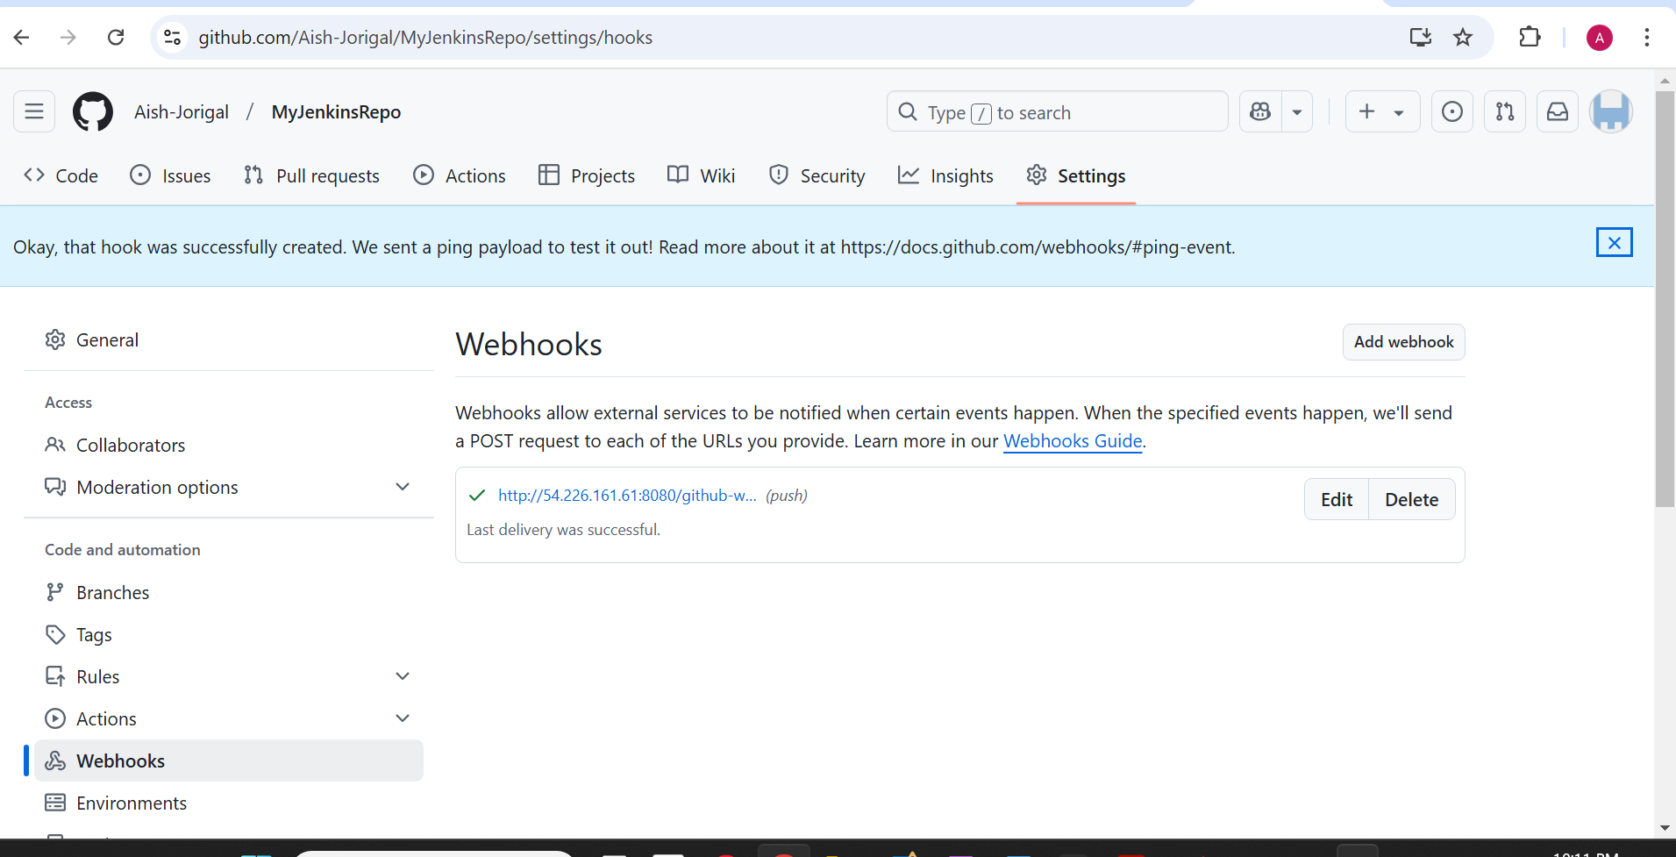

Now create job

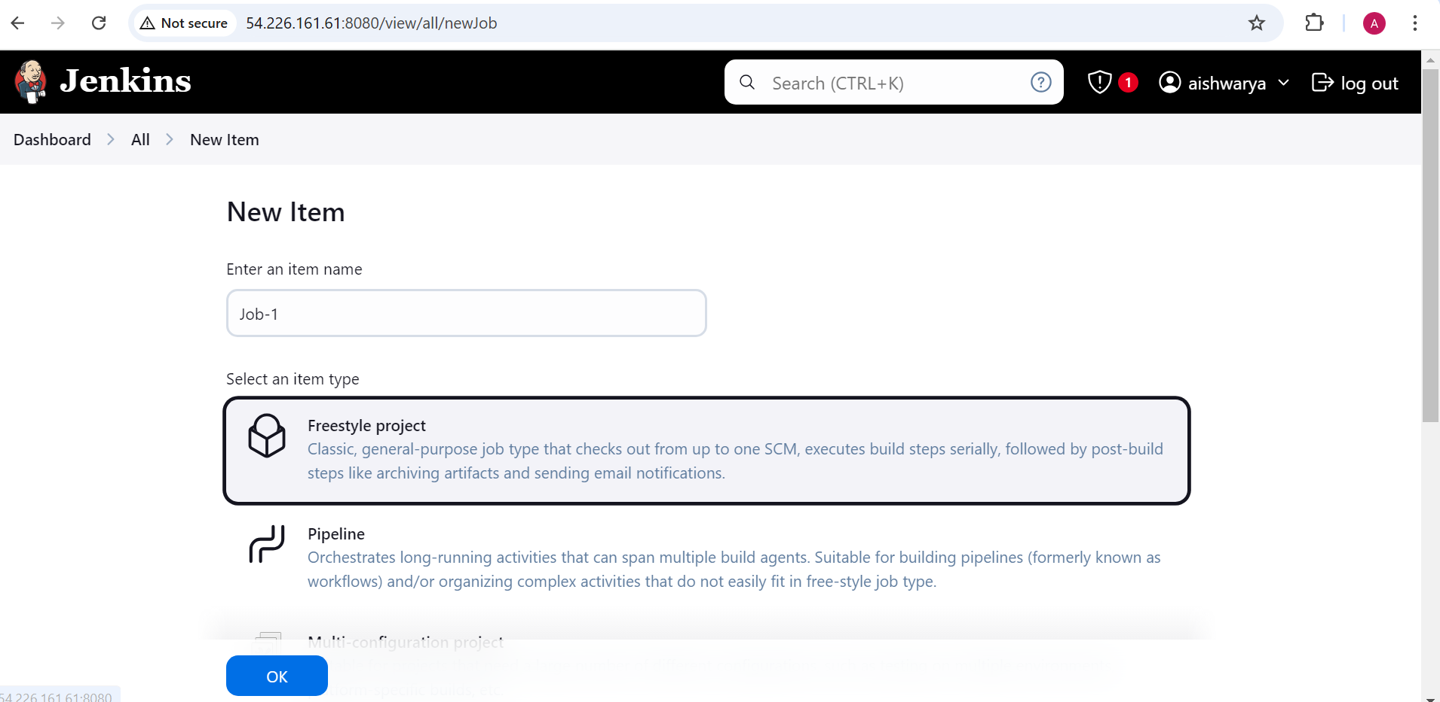

Restrict to work on Agent-1 machine

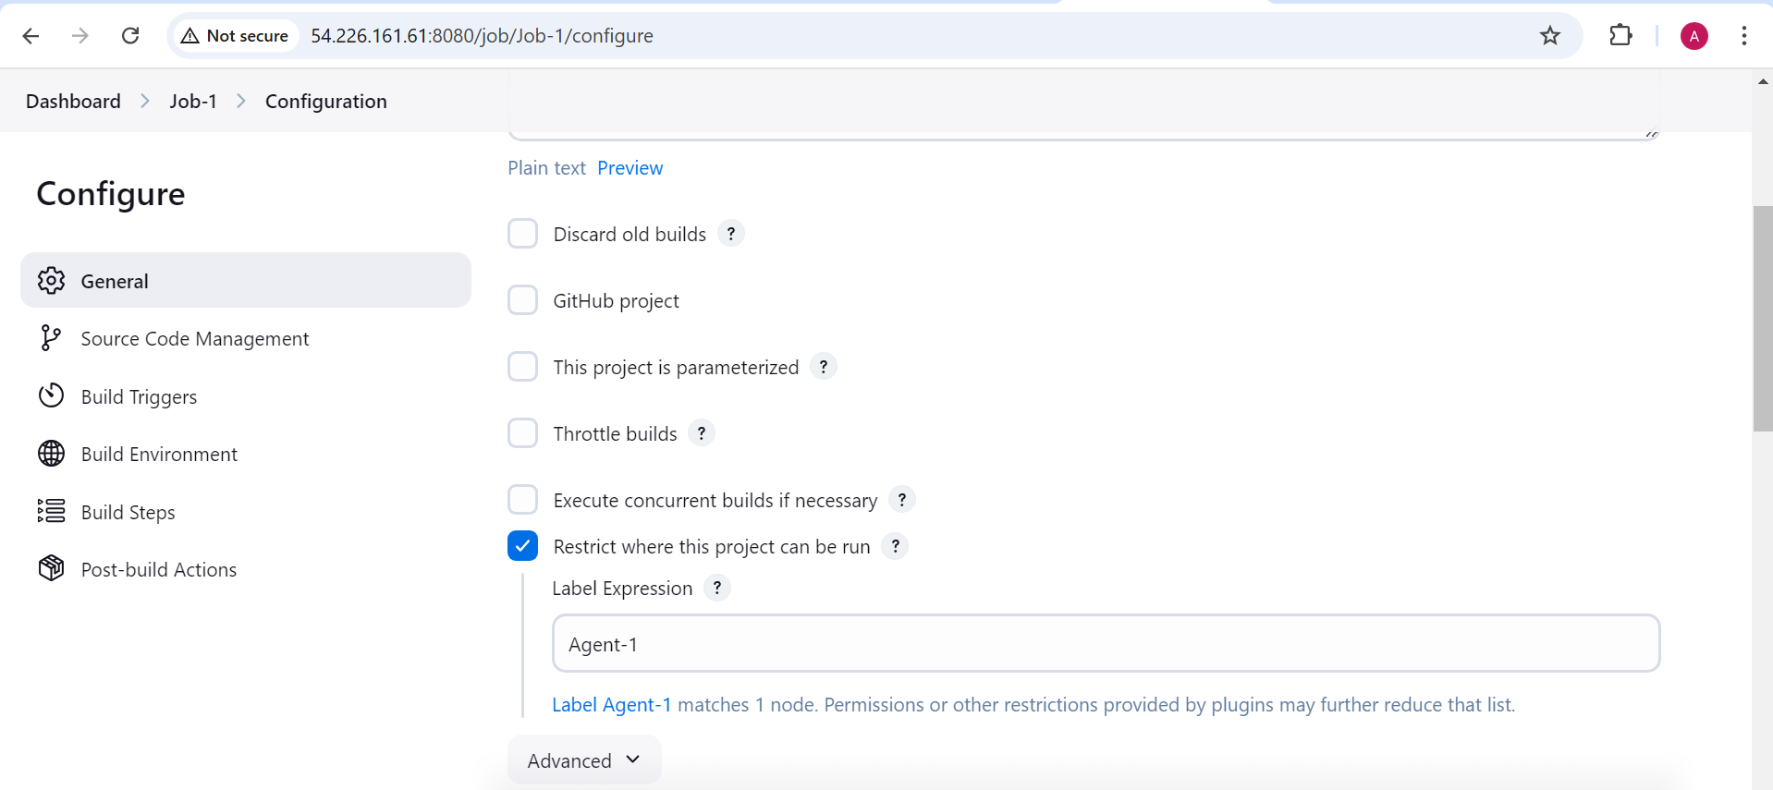

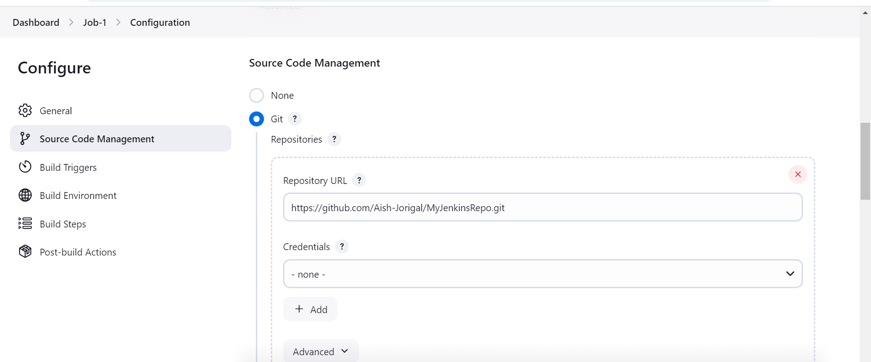

Specify the branch name

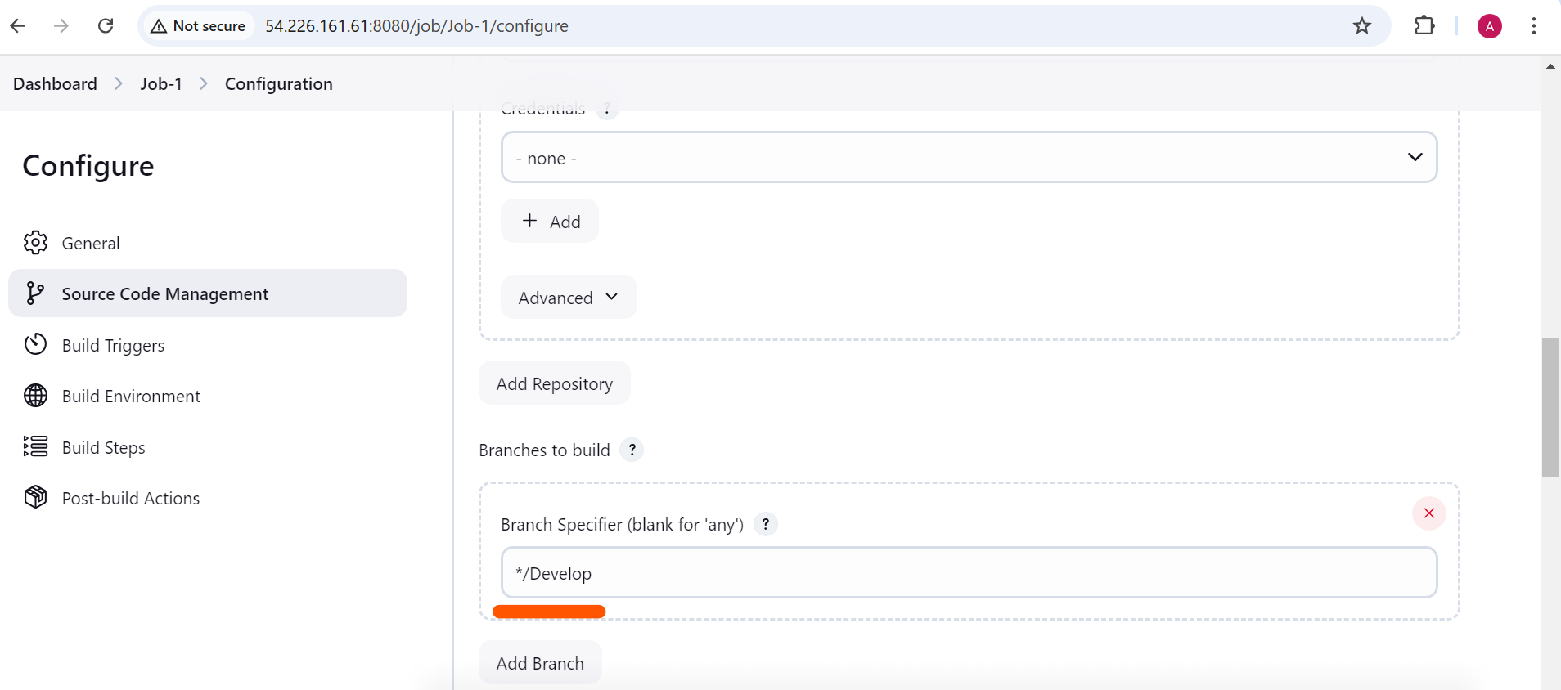

To trigger job when push was done on develop branch

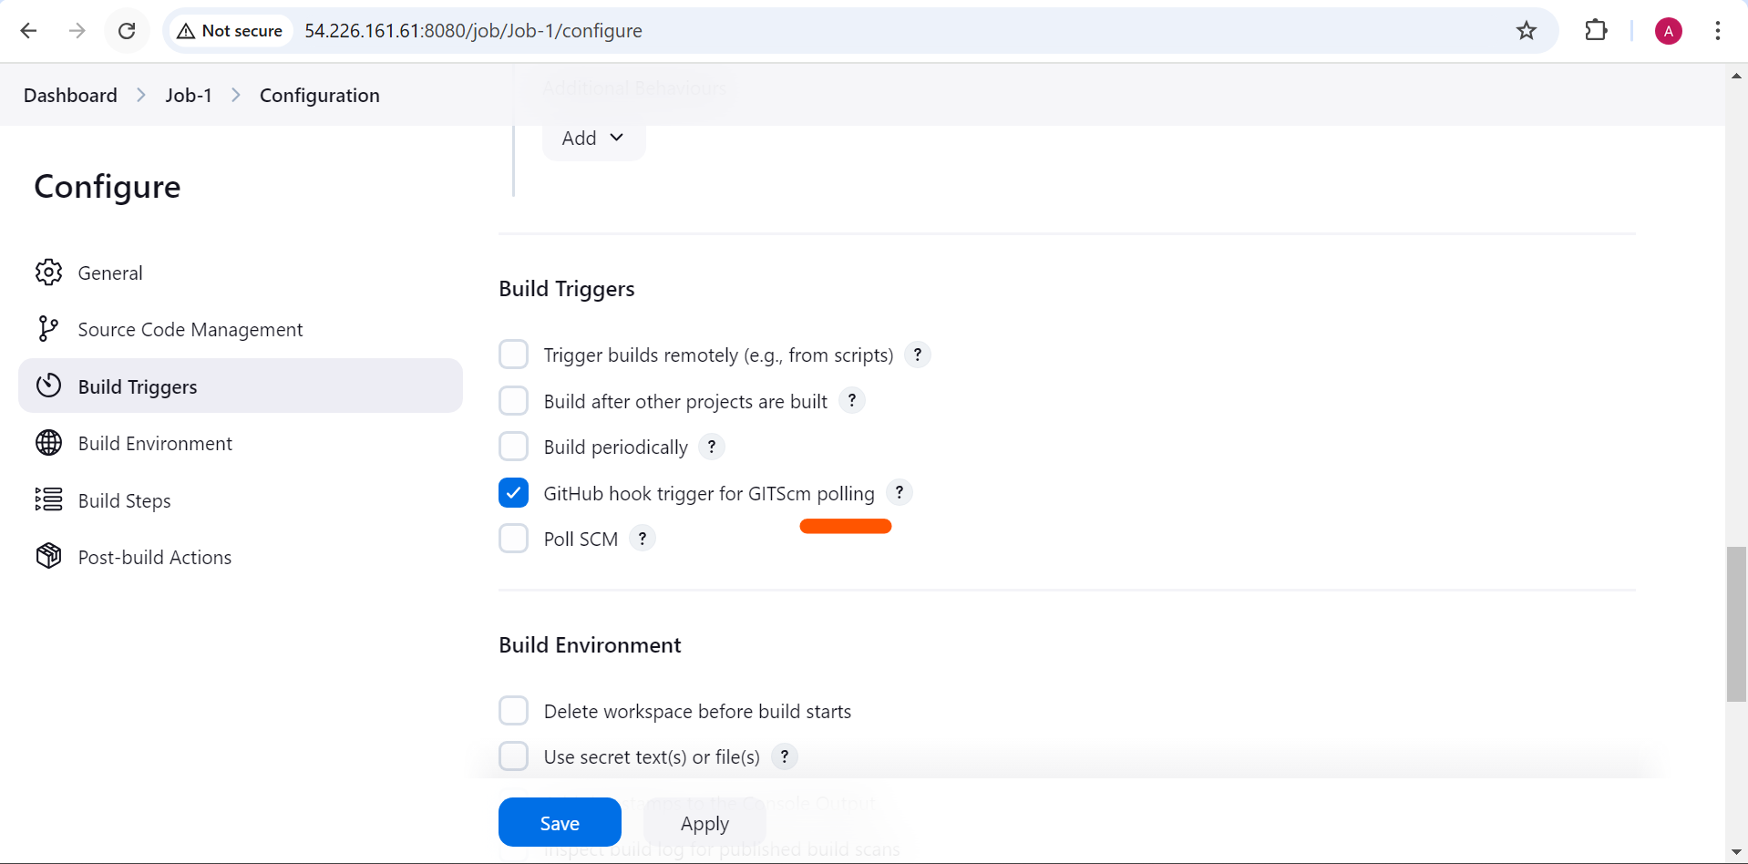

To test it:

On develop branch

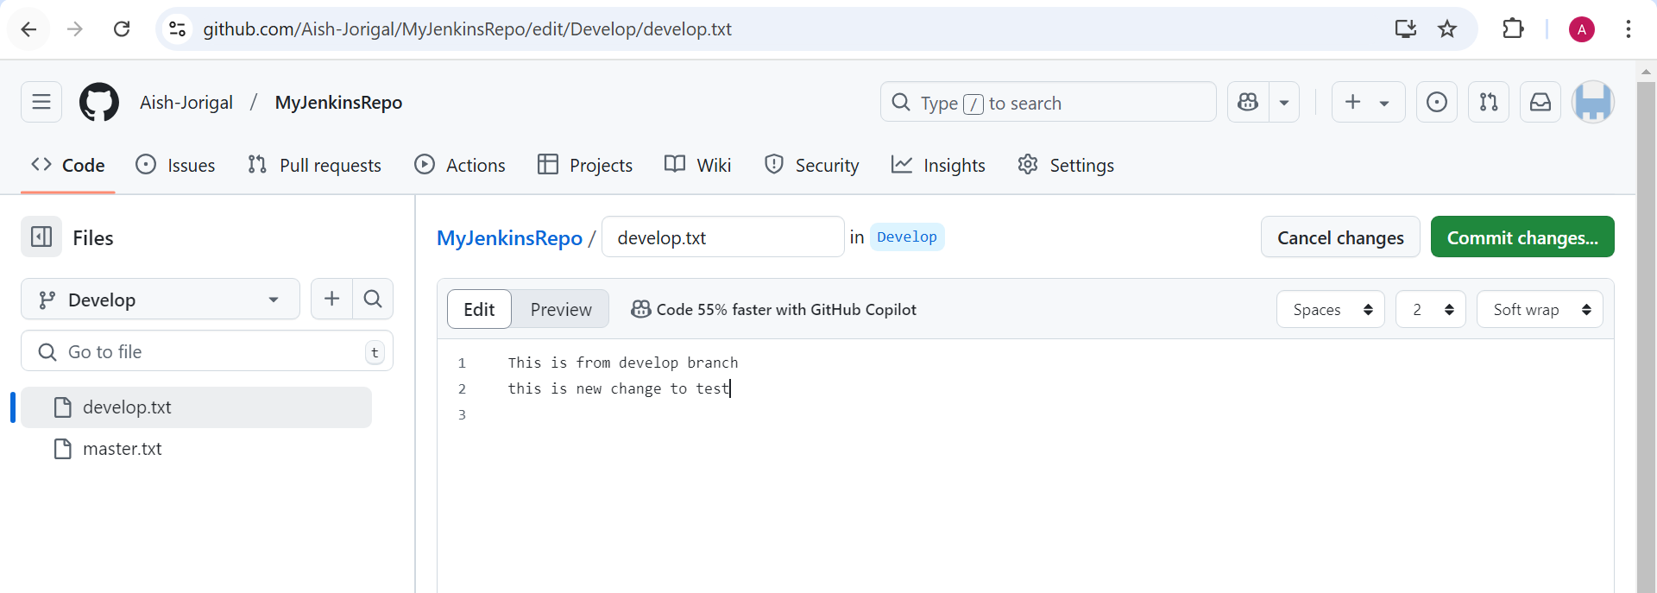

After committing the job is executing

